PEACE OF MIND DNA PATERNITY TESTING  Please write in clear block capitals  If you are looking to carry out another type of test e.g. legal test, sibling test, please contact us on 01603 358161. | 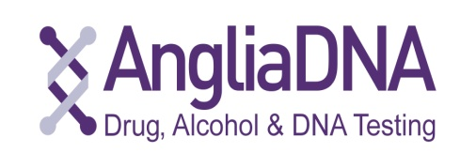

PARTIES TO BE TESTED
Mother | Full Name: Date of Birth:
Address:

Postcode:
 | Telephone:
Child | Full Name: Date of Birth:
Address:

Postcode:
 | Telephone:
Father | Full Name: Date of Birth:
Address:

Postcode:
 | Telephone:
IMPORTANT INFORMATION
Could a close relative (e.g. brother/sister) of the alleged father/mother potentially be the father/mother of the child being tested? Yes No If yes, please contact us and provide details here:

Could the mother and alleged father be biologically related (e.g. cousins, brother and sister)?
Yes No If yes, please contact us and give details here:

LEVEL OF SERVICE
Please indicate the level of service you require by ticking one box. Times commence from when Anglia DNA has received all samples, appropriate consent and identification from all parties.
Standard service (results available next working day) £99
Express service (results available same working day) £250
NOMINATED PERSON
Please indicate the person to whom the Test Report should be sent and with whom the results may be discussed (ONE NAME ONLY). Please refer to Anglia DNA’s Terms and Conditions for further details.
Full Name:
Address:

Postcode:
Email:
Telephone:
Please return completed form to Anglia DNA Services using the details at the bottom of the page.
OFFICE USE ONLY

